PRESENTING CLINICAL SIGNS
History: Flank mass.
Physical Examination: Large firm mass on the left side of the abdomen, tense abdomen.
Urinalysis: N/A.
CBC: Hemoconcentration.
Serum Biochemistry: Elevated creatinine.
Radiographic Findings: Mass that appears to extend from inside the abdomen.

ULTRASONOGRAPHIC EXAMINATION OF THE ABDOMEN
Urinary System
Full urinary bladder with a normal thickness and appearance of the wall. Normal anechoic urine with no sediment or uroliths evident.
Normal trigone area, proximal urethra, and iliac blood vessels.
Normal iliac lymph nodes. Ureters not visualized.
Normal renal size (left 4 cm, right 3.7 cm) with increased echogenic appearance, some loss of cortico-medullary differentiation, and normal pelvis and capsule.
Reproductive System
N/A.
Adrenal Glands
Normal shape, echogenic appearance, position, and size.
Spleen
Normal size and echogenic appearance. Smooth homogenous parenchyma, regular curvilinear capsule, and normal vasculature. No evidence of inflammatory, neoplastic, infarction, or infiltrative changes noted.
Liver
Normal size, echogenic appearance, portal markings, and regular curvilinear capsule. No nodules or masses evident. Full gall bladder containing normal anechoic bile. Normal appearance and thickness of the gall bladder wall. Normal bile duct.
Gastrointestinal
Normal appearance of the stomach, duodenum, small intestine, ileo-cecal junction, and colon with no loss of layering, normal wall thickness and peristaltic activity, and no distension of the lumen. Small amount fluid within the stomach.

Pancreas
Normal size and echogenic appearance. Normal echogenic appearance of the mesentery and fat surrounding the pancreas.
Free Abdomen
No mesenteric lymphadenomegaly.
No ascites.

ULTRASONOGRAPHIC FINDINGS
Primary Findings:
- Intra-abdominal lipoma.
Secondary Findings:
- Age-related renal changes.

INTERPRETATION OF THE FINDINGS & FURTHER RECOMMENDATIONS
The appearance the intra-abdominal mass is consistent with a lipoma with liposarcoma an unlikely differential diagnosis.
Further assessment that could be considered would be FNA cytology of the mass.
Surgical removal of the mass could be contemplated.

IMAGES
Abdominal mass
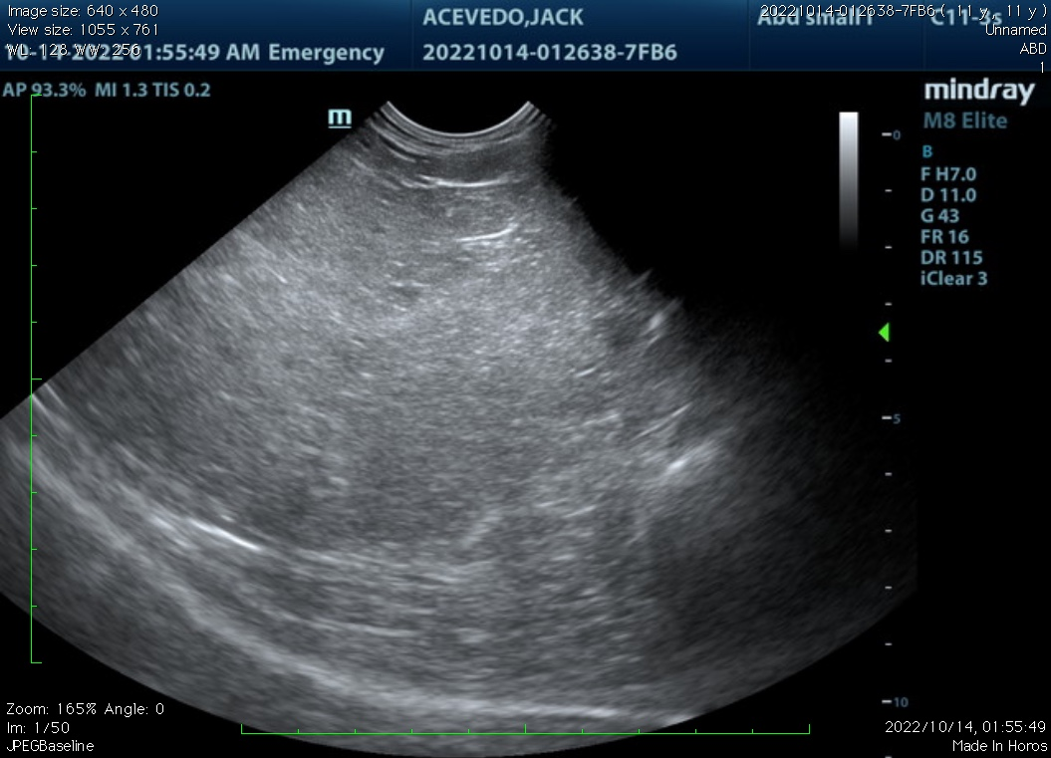
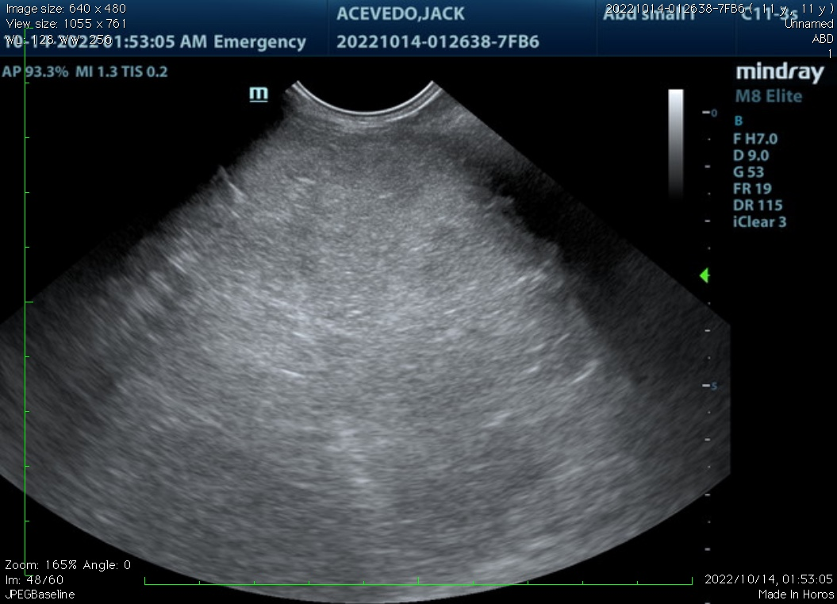

The information and recommendations provided are based on the images presented by the referring veterinarian. No evaluation can be communicated regarding pathology that was not visible in the image/video clips provided.

Thank you for this referral. If the clinical or image interpretation does not parallel your findings or if I can be of any further assistance, please contact me.

Remo Lobetti, BVSc, MMedVet (Med), PhD, Dipl. ECVIM (Internal Medicine)
rlobetti@mweb.co.za

